# CITP 155 – Programming I

## Loops Lab

## Graded Activity (20 points)

Provide any screen shots using the Snipping Tool and selecting only the relevant portion of the screen (instead of the entire screen). Provide any answers using a blue font. Please note that part of being a good programmer is being precise. If you have typos in your code, such as the words that are supposed to be displayed, you will not receive full credit.

KEEP ALL OF YOUR SOLUTION AND PROJECT FILES THROUGHOUT THE DURATION OF THE CLASS!

Concepts taken from <https://csharp.net-tutorials.com/control-structures/loops/>

**Questions (2 points)**

1. What is looping?

Looping is the process of repeating a block of code either when or until a condition is met.

1. List the four different kinds of looping and describe each one.

While loop: While a condition is met, a block of code will be executed.

Do loop: Like a while loop only the code is executed first and then the condition is checked to determine if it will execute again.

For loop: Will execute a block of code x number of times where x is either a given iteration or an iterative process determined by a set range limit ( i < 10 for instance).

For Each loop: Like a for loop this will execute a block of code x number of times, but in this case x will be an iteration through a list or an array not simply a number.

**Create a New Visual Studio Visual C# Console Application Project (1 point)**

Project Name: Months

Location: c:\users\student\documents\visual studio 2015\Projects\LastName_FirstName

Solution Name: Calendars

Provide a screen shot of the New Project screen before clicking OK.

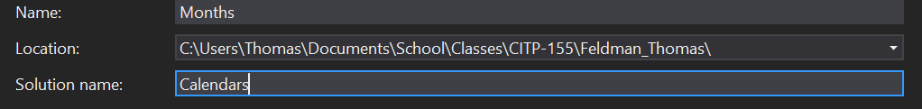

**Open and Modify Your C# Program**

Using the coding examples found at <https://csharp.net-tutorials.com/control-structures/loops/> as a guide, create a program that does the following:

* Declare a variable named **dayOfMonth** that is **int** data type. Initially set the variable to **1**.
* Write a while loop that will display the days of the month of June to the console.  
  You will need to concatenate the word **June** with the value of the variable **dayOfMonth** and increment the variable in every iteration of the loop. In order to do this, you need to know how many days June has. Your results will look something like this:  
  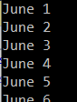
* Test your program.
* Set **dayOfMonth** back to an appropriate value for the next chunk of logic.
* Write a do loop that will display the days of the month of December to the console.  
  You will need to concatenate the word **December** with the value of the variable **dayOfMonth** and increment the variable in every iteration of the loop. In order to do this, you need to know how many days December has. Your results will look something like this:  
  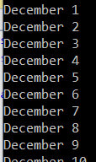
* Test your program.
* Write a for loop that will display the days of the month of March to the console. You will need to concatenate the word **March** with the value of the variable you choose to use as the counter. You will need to increment the variable in every iteration of the loop. In order to do this, you need to know how many days March has. Your results will look something like this:  
  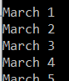
* Test your program.
* Make sure the console pauses at the end so the messages can be read by the end user.

**Provide Results (17 points)**

Place a debug breakpoint at the beginning of the do loop.

Test the program (run the debugger).

Provide a screen shot of your testing at the first breakpoint. At this point, only the days in the month of June should be displayed. The screen shot should include the title bar of the console with the full path of the program and all the lines of output for June, as well as the blank line below the June days. You may have to enlarge the size of the console window to get all of this in one screen shot.

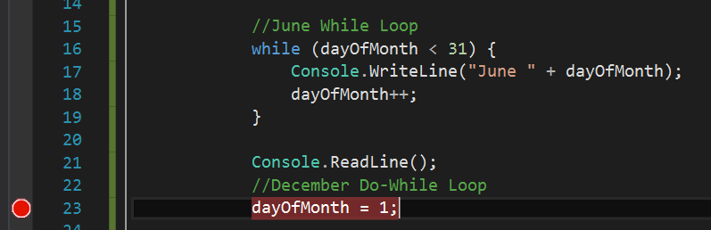

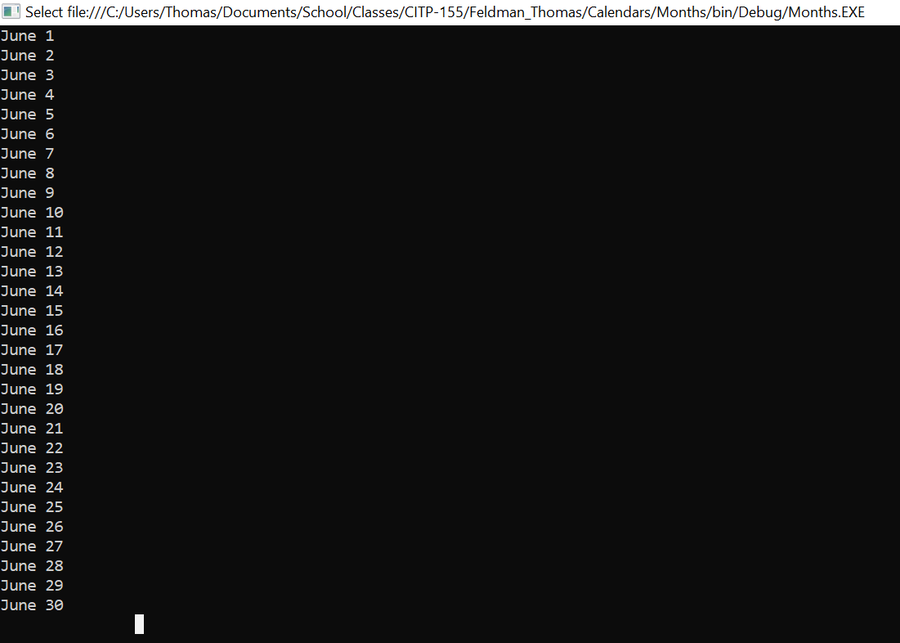

Provide a screen shot of the Autos debug window which shows the value of at least one variable at this point.

I was not able to see any variables in the autos window, I’m not sure what I did wrong or how to fix it.

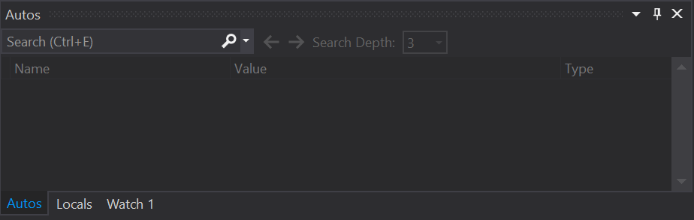

Exit the debug session.

Copy and paste the lines of code from your program here. This is not a screen shot. This is code I can copy and paste to run on my own. This should be 30-40 lines of code, depending on how many blank lines you left in between other lines of code.

static void Main(string[] args)

{

int dayOfMonth = 1;

//June While Loop

while (dayOfMonth < 31) {

Console.WriteLine("June " + dayOfMonth);

dayOfMonth++;

}

Console.ReadLine();

//December Do-While Loop

dayOfMonth = 1;

do

{

Console.WriteLine("December " + dayOfMonth);

dayOfMonth++;

} while (dayOfMonth < 32);

//March For Loop

dayOfMonth = 1;

for(int i = dayOfMonth; i < 32; i++)

{

Console.WriteLine("March " + i);

}

Console.ReadLine();

}